Part of: Sorting & Limiting Data:-To retrieve sorted and limited data from the E-Commerce database using SQL.

- Table Used:
Products and Order

- Task Description:
Fetch the top 5 most expensive products from the products table.

- SQL Query:
SELECT * FROM products ORDER BY price DESC LIMIT 5;

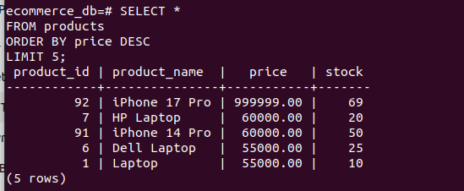
- Explanation:
This query sorts the products in descending order based on price using the ORDER BYclause.
The LIMIT clause restricts the output to only the top 5 most expensive products.

- Assumption:
Products with higher prices are considered premium products.

Sorting Data (ORDER BY)

- SELECT * FROM users ORDER BY name;

